**DESIGN AND IMPLEMENTATION OF AN ORDER REVIEW E-COMMERCE SYSTEM WITH PAYMENT ON DELIVERY SUPPORT**

BY

**OKEREKE** CHIMEMEZIEM DANIEL

BU/23A/IT/8106

The Faculty of Computing & Applied Sciences

BAZE UNIVERSITY

ABUJA

SEPTEMBER, 2025

**DESIGN AND IMPLEMENTATION OF AN ORDER REVIEW E-COMMERCE SYSTEM WITH PAYMENT ON DELIVERY SUPPORT**

Thesis Submitted in Partial Fulfillment of the Requirement for the Degree of

B. Sc.

In

Computer Science [INFORMATION SYSTEM MANAGEMENT]

By

**OKEREKE** CHIMEMEZIEM DANIEL

To

*The Faculty of Computing & Applied Sciences*

Baze University, Abuja

SEPTEMBER, 2025

**DECLARATION**

This is to certify that this project entitled **Design And Implementation Of An Order Review E-Commerce System With Payment On Delivery Support**, which is submitted by **Okereke Chimemeziem Daniel** in partial fulfilment of the requirement for the award of degree for B.Sc. in Information System Management to the Department of Computer Science, Baze University Abuja, Nigeria, comprises of only my original work and due acknowledgement has been made in the text to all other materials used.

Date: 09/ 2025 Okereke Chimemeziem Daniel:

**APPROVED BY** ……………………………

**Head**

Department of Computer Science

**CERTIFICATION**

This is to certify that this project entitled **Design And Implementation Of An Order Review E-Commerce System With Payment On Delivery Support**, which is submitted by **Okereke Chimemeziem Daniel** in partial fulfilment of the requirement for the award of degree for B.Sc. in Information Technology to the Department of Computer Science, Baze University Abuja, Nigeria is a record of the candidate’s own work carried out by the candidate under my/our supervision. The matter embodied in this project is original and has not been submitted for the award of any other degree.

Date: Supervisor: Dr. Usman Abubakar

**APPROVAL**

This is to certify that the research work, **Design And Implementation Of An Order Review E-Commerce System With Payment On Delivery Support** and the subsequent preparation by **Okereke Chimemeziem Daniel** with **BU/23A/IT/8106** has been approved by the Department of Computer Science, Faculty of Computing and Applied Science, Baze University, Abuja, Nigeria.

By

Dr Usman Abubakar Date/Sign

Supervisor

Dr Abubakar Idris Usman Date/Sign

Head, Department of Compuer Sciences

Prof Rufai Aliyu Yauri Date/Sign

Dean, Faculty of Computing and Applied Science

External Examiner Date/Sign

**DEDICATION**

[This is the dedication page.]

**ABSTRACT**

[The abstract provides a clear summary of the project, indicating both content and tone of the project. An abstract includes the method(s) used to analyze the problem, a brief description of the research design, a listing of the key results, a brief description of the significance of the results, selected key conclusions. First-person narrative should not be used in the abstract.]

# TABLE OF CONTENT

**DECLARATION** 3

**CERTIFICATION** 4

**APPROVAL** 5

**DEDICATION** 6

**TABLE OF CONTENT** 8

**LIST OF TABLES** 11

**LIST OF FIGURES** 12

**LIST OF ABBREVIATION** 13

**CHAPTER 1: INTRODUCTION** 2

1.1 Overview 2

1.2 Background and Motivation 4

1.2.1 Background 4

1.2.2 Motivation 4

1.3 Statement of the Problem 6

1.4 Aims and Objectives 7

1.4.1 Aim 7

1.4.2 Objectives 7

1.5 Significance of the Project 8

1.6 Project Risks Assessment 9

1.7.1 Scope 10

1.7.2 Project Organization 10

**CHAPTER 2: LITERATURE REVIEW** 12

2.1 Introduction 12

2.2 Historical Overview 13

2.3 Related Work 16

2.4 Summary 18

**CHAPTER 3: REQUIREMENTS, ANALYSIS, AND DESIGN** 19

3.1 Overview 19

3.2 Proposed Model 20

3.3 Methodology 21

3.3.1 Date Gathering Method 21

3.4 Tools and Techniques 23

3.5 Ethical Consideration 25

3.6 Requirements Specifications 26

3.6.1 Functional Requirements Specifications 26

3.6.2 Non-Functional Requirement Specifications 27

3.6.3 System Requirements Specifications 28

3.7 System Design 30

3.7.1 Application Diagram 30

3.7.2 Use case diagram 31

3.7.3 Entity-Relationship Diagram (ERD) 33

3.7.4 Data Design 34

3.7.5 Activity Diagrams 36

3.7.6 Data Flow Diagram 37

3.7.7 Control Flow Diagram 37

3.7.8 User Interface Design 39

3.9 Summary 42

**CHAPTER 4: TESTING AND IMPLEMENTATION** 43

4.1 Overview 43

4.2 Main Features 44

4.3 Implementation Problems 53

4.4 Overcoming Implementation Problems 54

4.5 Testing 55

4.5.1 Test Plans (For Unit, Integration and System Testing) 55

4.6 Use Guide 60

4.6.2 User Guide 60

4.7 Summary 63

**CHAPTER 5: DISCUSSION, CONCLUSION, AND RECOMMENDATIONS** 64

5.1 Overview 64

5.2 Objective Assessment 65

5.3 Limitations and Challenges 66

5.4 Future Enhancements 67

5.5 Recommendations 68

5.6 Summary 69

**REFERENCES** 70

**Appendix A - Project Document** 73

Background and Motivation 73

Statement of the Problem 74

**Appendix B – Model Training and Data Collection** 75

**Appendix C- Source Codes** 80

**LIST OF TABLES**

TABLE 1.1 *PROJECT RISK ASSESSMENT*

TABLE 3.1 *FUNCTIONAL REQUIREMENTS*

TABLE 3.2 *NON-FUNCTIONAL REQUIREMENTS*

TABLE 3.3 *SOFTWARE REQUIREMENTS*

TABLE 3.4 *HARDWARE REQUIREMENTS*

**LIST OF FIGURES**

FIGURE 3.1 - *APPLICATION DIAGRAM OF THE USER VIEW*

FIGURE 3.2 - *APPLICATION DIAGRAM OF THE ADMIN VIEW*

FIGURE 3.3 – *USE CASE DIAGRAM*

FIGURE 3.4 – *ERD (ENTITY-RELATIONSHIP DIAGRAM) DIAGRAM*

FIGURE 3.5 – *ACTIVITY DIAGRAM SHOWING HOW THE USER WOULD INTERACT WITH THE SYSTEM*

FIGURE 3.6 - *DATA FLOW DIAGRAM*

FIGURE 3.7 – *USER CONTROL FLOW DIAGRAM*

**LIST OF ABBREVIATIONS**

# CHAPTER FOUR

# RESULTS AND DISCUSSION

## 4.1 Design and Implementation Results

This section presents the design and implementation of Subme online application for making orders online.

## 4.2 Homepage

The homepage for the design subme consists of the following features; Products, Cart, My Orders, register, all categories and the Search tabs, as presented in Figure 4.1.

The functions of each of these tabs are hereby explained in the succeeding subsections that follows.

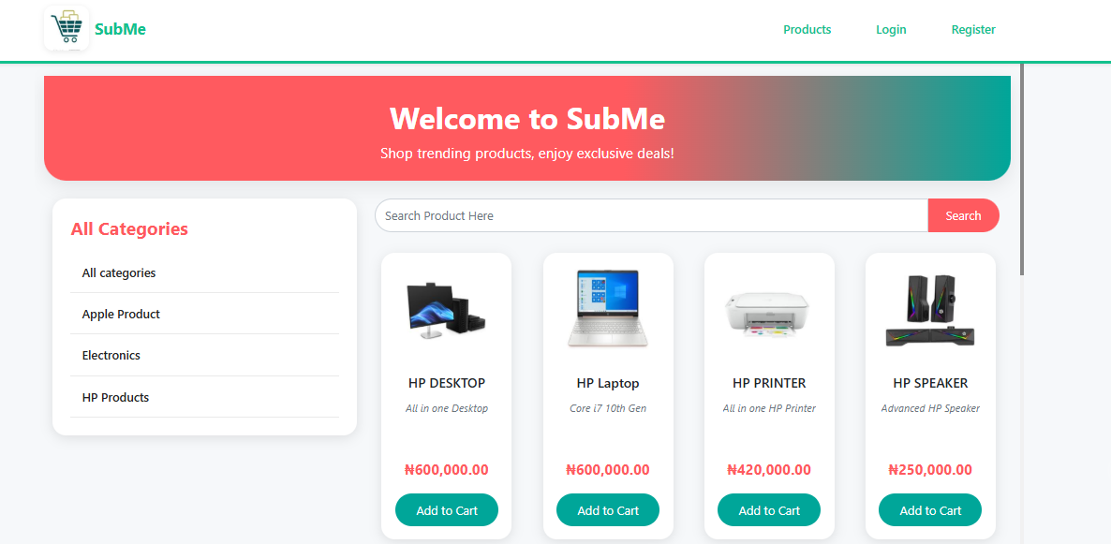

**Figure 4.1** Homepage

## 4.2 The Register Tab

The register tab presented in Figure 4.2, enables new clients/user who will like to make use of the Subme platform for purchase to register first, thereafter, the client/user can explore the full features of Subme.

New client/user need to provide the following details to register on the Subme platform; full name, username, email, password, contact and address. Thereafter, the new client/user can click on create account for such client/user to become active.

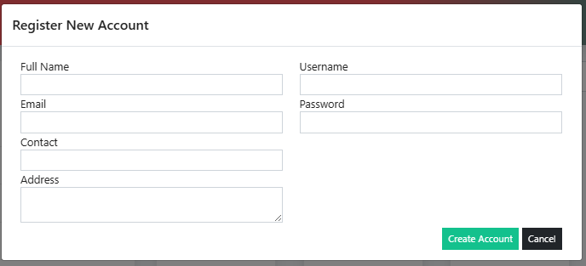

**Figure 4.2** Register Tab

A successful registered client/user will now need to provide login details before he/she can now login to Subme platform, Figure 4.3 presents the interface credential Login page for client/user to provide login details, such as username and password before the client/user can now click on Login to get access.

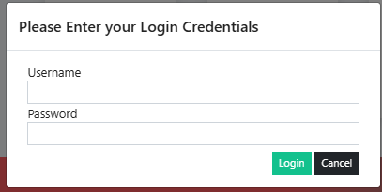

**Figure 4.3** Credential Login Page

## 4.3 Login Welcome Page

The Login Welcome page presented in Figure 4.4, compose of the following features; the registered tab now changed to the name of the registered new client/user with the “Hello” word attached to the client/user name. The client/user can now have access to view, select, add and make order of products.

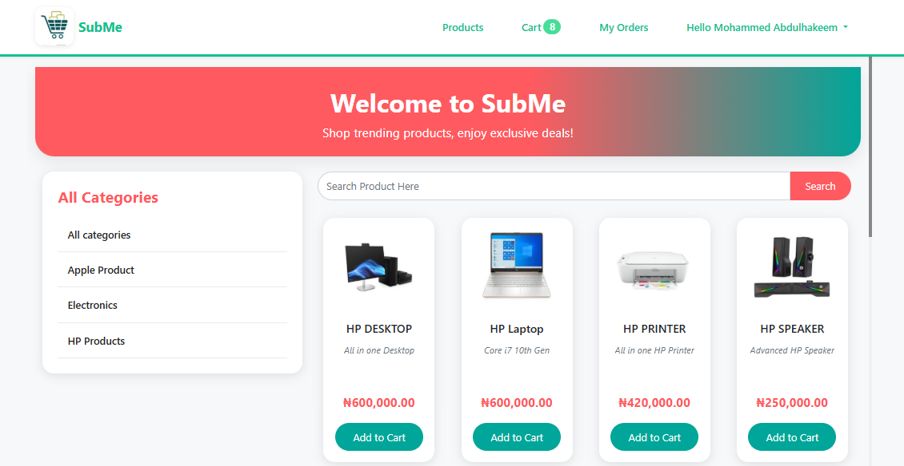

**Figure 4.4** Login Welcome Page

### 4.3.1 Add to cart

The Add to Cart is a feature that enable registered client/user to select product(s) of choose and add to cart, for forward onward delivery. In this interface, product name can be view, alongside the specification as well as the cost. After the registered client/user click on Add to Cart, a confirmation popup appears and then the registered client/user can click on ok. Figure 4.5 present the Add to Cart interface.

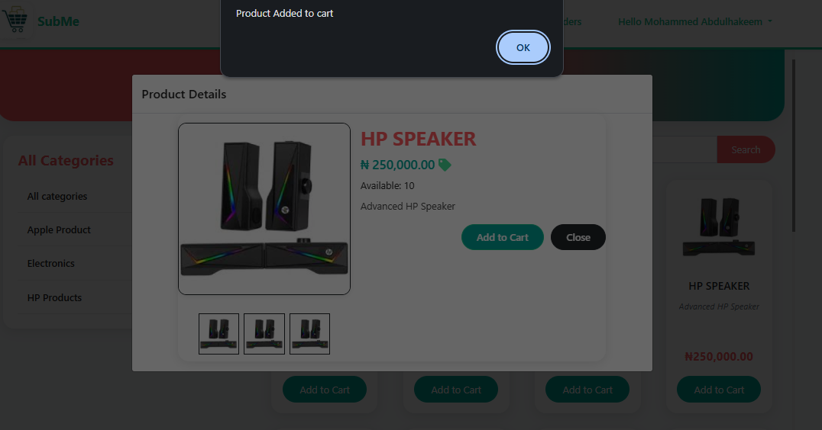

**Figure 4.5** Add to Cart Interface

### 4.3.2 Cart Interface

The Cart interface presented in Figure 4.6 is the feature that shows product(s) that have been selected and added to the cart by the registered client/user. The number of products ordered can be seen displayed at the Cart tab, of which from the Figure 4.6, it can be seen as 1, the amount of the product can also be seen. The registered client/user can now proceed to click on checkout, which servs as the final confirmation of the ordered product, registered client/user still have the option of deleting the product using the delete icon tab, if such client/user no longer wish to proceed with the ordered product.

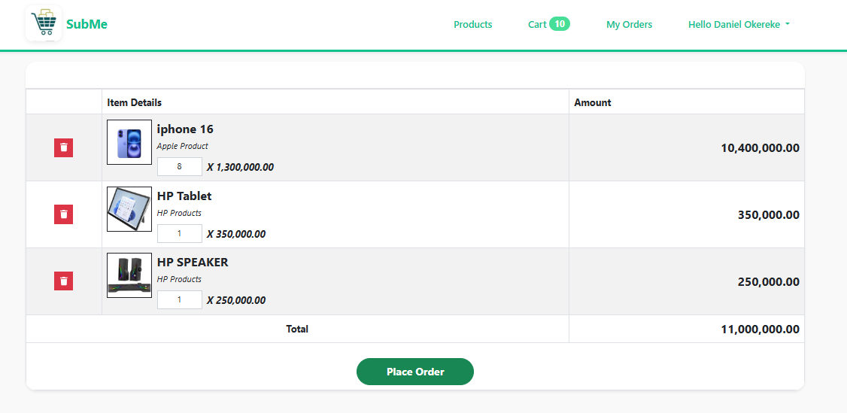

**Figure 4.6** Add to Cart interface

### **4.3.3** Checkout Interface

The Checkout interface precede the Cart interface have the features of Delivery Location, from which the registered client/user can select where the ordered product can be delivered, and then the Delivery Address Other Information which is the detailed point of locating the registered client/user.

Thereafter, the registered client/user can now click on Place Order or Cancel tab to conclude the Checkout process.

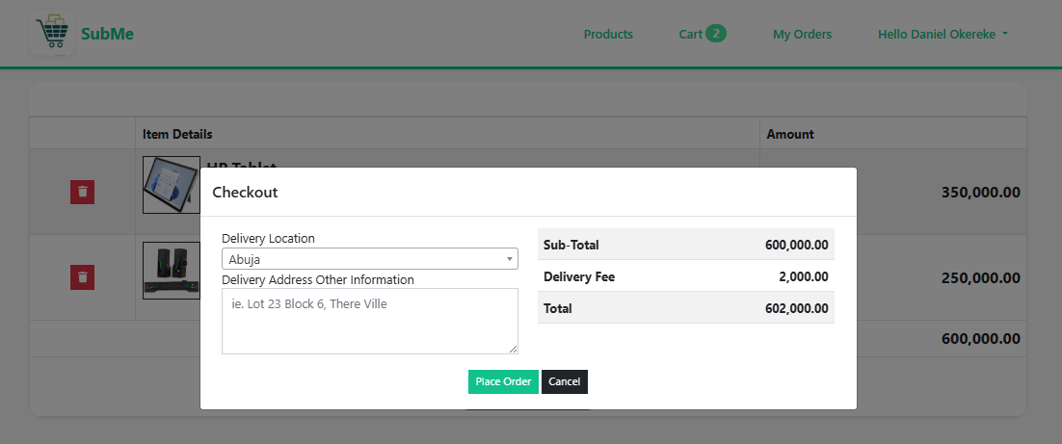

**Figure 4.7** Checkout Interface

A successful checkout will lead the registered client/user to the next page “Order successfully placed.” as presented in Figure 4.8, and next is the Order List and Order Detail interface.

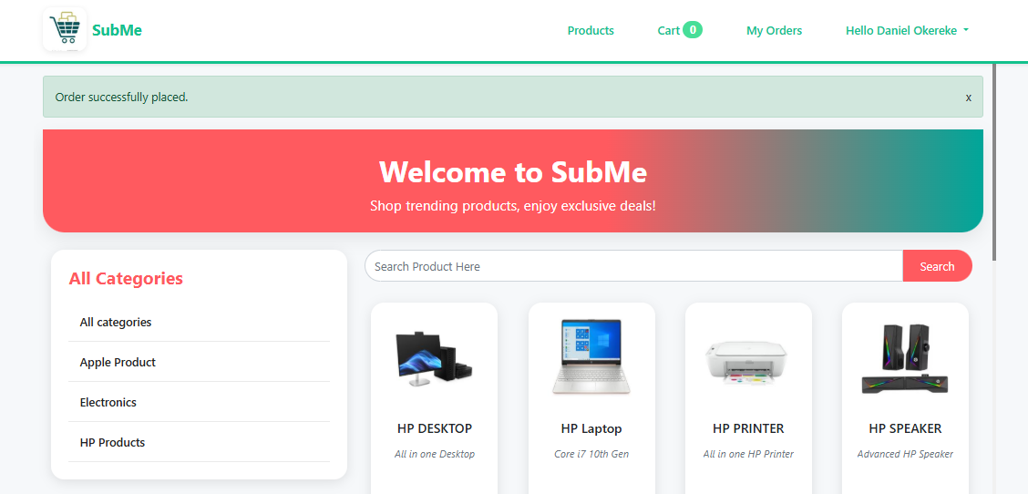

**Figure 4.8** Order Successfully Placed Interface

## 4.4 Oder List Interface

The Order List interface gives the registered client/user a preview of product ordered with details like DateTime Created, Transaction Pode, Customer Name, Items, Total Amount, Status and Action. Giving information about when product order was initiated, the transaction identification number, the registered client/user name, number of products ordered, summary of the product cost, the delivery state and the action which enable the ordered detail view respectively. Figure 4.9 present the Order List interface.

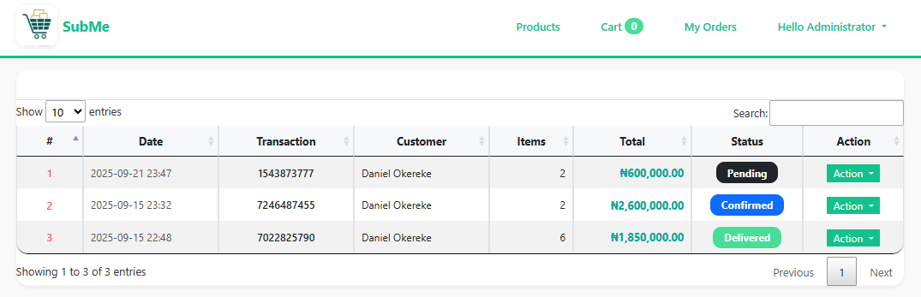

**Figure 4.9** Order List Interface

### 4.4.1 The Action Tab

The Action tab which has the View dropdown feature as presented in Figure 10, gives access to the registered client/user full summary of the product (Order Details) been ordered such as the Transaction Pode, the Status, Date Created and Delivery Address as discussed in the preceding subsections. Other information that can be seen are the Quantity (QTY) of ordered product, the specification (Item Details) as well as the cost of the product ordered (Amount). Figure 4.11 depicts the View dropdown detail from the Action tab.

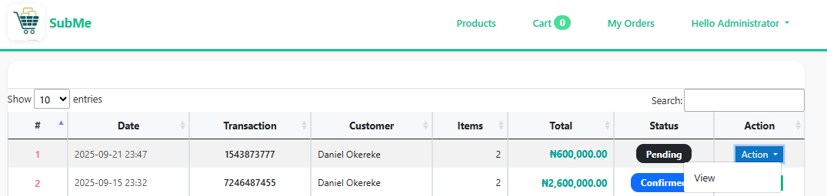

**Figure 4.10 T**he Action Tab

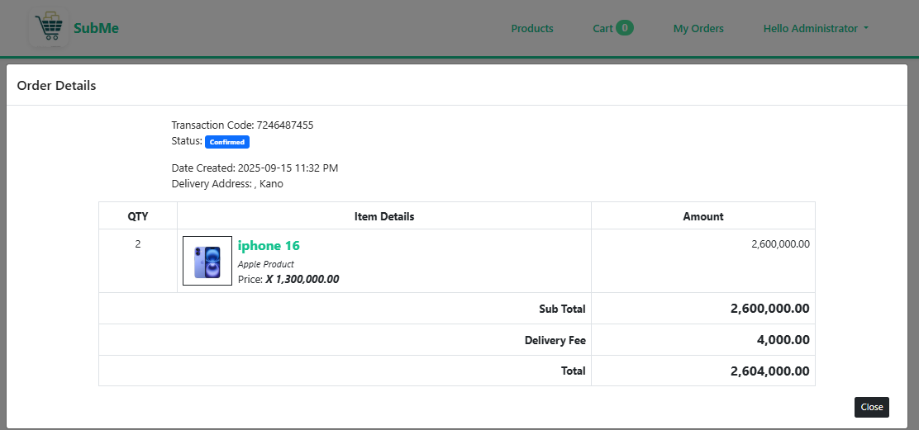

**Figure 4.11** The View Dropdown Detail from the Action Tab.

### 4.4.2 Manage Account Tab

The Manage Account Tab Figure 4.12 has the dropdown feature of Logout, that is to exit the Subme platform.



**Figure 4.12** Manage Account Tab

The Manage Account Function allows the registered client/user to update their details such as Full Name, Contact, Email, Address, and Username, as shown in Figure 4.13. The registered client/user can also decide to make changes to his or her password in this interface as well, after all operation are done successfully, the registered client/user can now click on update tab to complete the process of updating his or her information on the Subme platform.

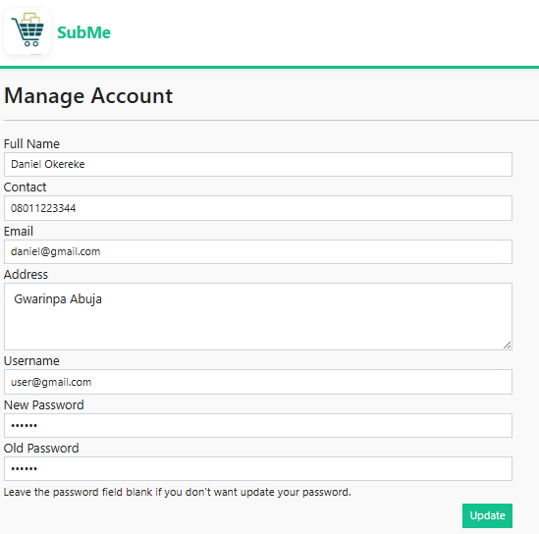

**Figure 4.13** The Manage Account Function Interface

**REFERENCE**

Jain, V., Malviya, B. I. N. D. O. O., & Arya, S. A. T. Y. E. N. D. R. A. (2021). An overview of electronic commerce (e-Commerce). Journal of Contemporary Issues in Business and Government, 27(3), 666.

Nasution, M. D. T. P., & Surya, D. H. (2025). Reassessing Payment Methods in E-Commerce: Why Consumers Prefer Cash on Delivery. Journal Business Administration: Entrepreneurship and Creative Industry, 4(1), 22-30.

Rayport, J. F., & Jaworski, B. J. (2003). Introduction to e-commerce. McGraw-Hill, Inc..

Halaweh, M. (2018). Cash on delivery (POD) as an alternative payment method for e-commerce transactions: Analysis and implications. International Journal of Sociotechnology and Knowledge Development (IJSKD), 10(4), 1-12.

Heng, M. S. (2003). Understanding electronic commerce from a historical perspective. Communications of the Association for Information Systems, 12(1), 6.

Okofu, S. N., Bisina, J., Okumoku-Evroro, O., & Akazue, M. I. (2024). CASH ON DELIVERY RISK MITIGATION CMRR MODEL. Journal of the Management Sciences, 61(9), 142-155.

Anjum, S., & Chai, J. (2020). Drivers of payment-on-delivery method of payment in e-commerce shopping: evidence from Pakistan. Sage Open, 10(3), 2158244020917392.

Alfarizi, M., & Sari, R. K. (2023). Adoption of cash on delivery (POD) payment system in shopee marketplace transaction. Procedia Computer Science, 227, 110-118.

Bakar, R., Fauziyah, N., & Rahmat, A. (2025). Do consumers perceive impulsive buying and pain of payment?: E-commerce transactions using pay later, e-wallet, and cash-on-delivery. Gadjah Mada International Journal of Business, 27(1), 31-59.

Kabir, M. A., Saidin, S. Z., & Ahmi, A. (2015, October). Adoption of e-payment systems: a review of literature. In International conference on e-commerce (pp. 112-120).

Panetta, I. C., Leo, S., & Delle Foglie, A. (2023). The development of digital payments–Past, present, and future–From the literature. Research in International Business and Finance, 64, 101855.

Usman P.J (2022) Design and implementation of an e-commerce system.

Hendricks, S., & Mwapwele, S. D. (2024). A systematic literature review on the factors influencing e-commerce adoption in developing countries. Data and Information Management, 8(1), 100045.

Yusuf, A., Gaffar, V., Hurriyati, R., & Wibowo, L. A. (2022, December). E-trust in e-commerce: a systematic literature review. In 3rd Borobudur International Symposium on Humanities and Social Science 2021 (BIS-HSS 2021) (pp. 638-644). Atlantis Press.

Mumu, J. R., Saona, P., Mamun, M. A. A., & Azad, M. A. K. (2022). Is trust gender biased? A bibliometric review of trust in E-commerce. Journal of Internet Commerce, 21(2), 217-245.

Vatrapu, S. R. (2014) Design and Implementation of E-Commerce Site for Online Shopping. All Capstone Projects. 79. <https://opus.govst.edu/capstones/79>

Rihidima, L. V. C., Abdillah, Y., & Rahimah, A. (2022). Adoption of Cash on Delivery Payment Method in E-commerce Shopping: A Value-based Adoption Model Approach. Jurnal Manajemen Teori dan Terapan, 15(3).

Zhang, Y and Wang, R. (2014). Comparison of E-payment of the B2C E-commerce in China from the Security and Trust Perspective. International Journal of Security and Its Applications8(3), 325-338

Achiando, H. A. (2019). E-commerce strategy adoption and performance of micro and small enterprises: A case of private security firms in Nairobi County, Kenya. IOSR Journal of Business and Management, 21(7), 35-64.

Amobi, O.M. (2023). Advantages and disadvantages of cash on delivery in E-commerce. Retrieval from: [https://medium.com/@mariaamobi/advantage-and-disadvantages-of-payment-on-delivery-in-e-commerce-43f7b11962f9](https://medium.com/@mariaamobi/advantage-and-disadvantages-of-cash-on-delivery-in-e-commerce-43f7b11962f9)

Fastercapital, (2023). Simplifying payment: How Cash On Delivery Transforms Online Shopping. Retrieved from: [https://fastercapital.com/content/Simplifying-Payments--How-Payment-on-delivery-Transforms-Online-Shopping.html](https://fastercapital.com/content/Simplifying-Payments--How-Cash-on-Delivery-Transforms-Online-Shopping.html)

Sasu, D. D. (2022). E-commerce in Nigeria –Statistics and Facts. In Statista. <https://www.statista.com/topics/6786/e-commerce-in-nigeria/>.

Okofu, S. N., Bisina, J., Okumoku-Evroro, O., & Akazue, M. I. (2024). Cash on delivery risk mitigation cmrr model. Journal of the Management Sciences, 61(9), 142-155.

Chiejina, C., & Olamide, S. E. (2014). Investigating the Significance of the 'Pay on Delivery' Option in the Emerging Prosperity of the Nigerian e-commerce sector. Journal of Marketing and Management, 5(1), 120.